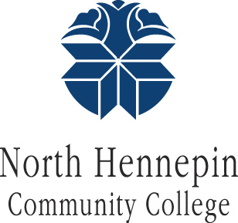 Office of Student Life|Campus Center
North Hennepin Community College
studentlife@nhcc.edu|763-424-0801

POPCORN MACHINE RESERVATION FORM
Name
Department/Organization
Purpose/Name of Event
Reservation Date(s) & Time
Pick Up Date & Time
Return Date & Time
Cost Center

I/We understand that the Popcorn Machine is the Property of Student Life and that I/We are held responsible for anything that may happen when the machine is in my/our control. I/We are to return the machine in the same condition it was found; cleaned and ready for the next event.
Student life reserve the right to limit the amount of popcorn supply given with the machine. Student Life will supply three courtesy packs of popcorn with butter when you pick up the machine. Reserving the popcorn machine DOES NOT include popcorn supply. You will need to supply your own popcorn and butter.
The Renter shall not during the reservation period allow others the use of the popcorn machine.
Sign: | Date:

Office Use Only:
Approved By: | Released By:

North Hennepin Community College is a member of the Minnesota State Colleges and Universities and an equal opportunity employer and educator. This document is available in alternative formats to individuals with disabilities by calling 763-493-0555 or through the Minnesota Relay Service at 1-800-627-3529. North Hennepin Community College’s Disability Access Services office can be reached at 763-493-0556.

Student Life Popcorn Machine
Supply List

Megapop8 - Mega-pop for 8oz popper
- Case Price: $31.00 per case
Popcorn, coconut oil, and flavacol portion pack kit for an 8 oz popcorn popper.
24/10.6 oz packages per case.
- Individual Pack Price: $1:30 each
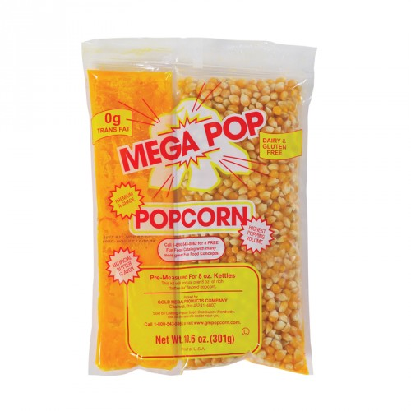
Popcorn, coconut oil, and flavacol portion pack kit for an 8 oz popcorn popper.
10.6 oz packages

Name: | Contact Info: | Case Quantity: | Individual Quantity: | Total Price:

